Exp 9 - Practising Multithreading java

1. Write a java program to create a thread using runnable interface.

package MultiThreading;

public class ThreadRunnable implements Runnable{

@Override

public void run() {

for (int i = 0; i < 10; i++) {

System.out.println("Inside thread i="+i);

}

}

public static void main(String[] args) {

Thread th = new Thread(new ThreadRunnable());

th.start();

}

}

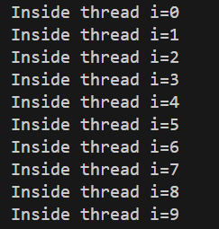

1. Write a java program by extending a thread class.

package MultiThreading;

public class ThreadExtendend extends Thread {

public void run(){

for (int i = 0; i < 10; i++) {

System.out.println("Inside thread i="+i);

}

}

public static void main(String[] args) {

new ThreadExtendend().start();

}

}

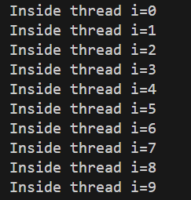

1. Write a java program to print even and odd numbers in different threads.

package MultiThreading;

class Even extends Thread{

@Override

public void run() {

for (int i = 0; i < 10; i=i+2) {

System.out.println("even no: "+i);

}

}

}

class Odd extends Thread{

@Override

public void run() {

for (int i = 1; i < 10; i=i+2) {

System.out.println("odd no: "+i);

}

}

}

public class EvenOddThread {

public static void main(String[] args) {

new Even().start();

new Odd().start();

}

}

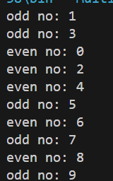

1. Write a java program that sorts an array of integer using multiple inheritance.